

# 

### Semester One Examination, 2016

### Question/Answer Booklet

# MATHEMATICS

If required by your examination administrator, please place your student identification label in this box

**METHODS**

**UNIT 3**

## Section One:

## Calculator-free

|  |  |  |  |  |  |  |  |  |
| --- | --- | --- | --- | --- | --- | --- | --- | --- |
| Student Number: In figures |  |  |  |  |  |  |  |  |

In words

Your name

## Time allowed for this section

Reading time before commencing work: five minutes

Working time for section: fifty minutes

## Materials required/recommended for this section

***To be provided by the supervisor***

This Question/Answer Booklet

Formula Sheet

***To be provided by the candidate***

Standard items: pens (blue/black preferred), pencils (including coloured), sharpener, correction fluid/tape, eraser, ruler, highlighters

Special items: nil

## Important note to candidates

No other items may be taken into the examination room. It is **your** responsibility to ensure that you do not have any unauthorised notes or other items of a non-personal nature in the examination room. If you have any unauthorised material with you, hand it to the supervisor **before** reading any further.

## Structure of this paper

|  |  |  |  |  |  |
| --- | --- | --- | --- | --- | --- |
| Section | Number of questions available | Number of questions to be answered | Working  time (minutes) | Marks available | Percentage of exam |
| Section One:  Calculator-free | 8 | 8 | 50 | 48 | 35 |
| Section Two:  Calculator-assumed | 13 | 13 | 100 | 101 | 65 |
|  | | | **Total** | 149 | 100 |

## Instructions to candidates

1. The rules for the conduct of examinations are detailed in the school handbook. Sitting this examination implies that you agree to abide by these rules.
2. Write your answers in this Question/Answer Booklet.
3. You must be careful to confine your response to the specific question asked and to follow any instructions that are specified to a particular question.
4. Spare pages are included at the end of this booklet. They can be used for planning your responses and/or as additional space if required to continue an answer.

* Planning: If you use the spare pages for planning, indicate this clearly at the top of the page.
* Continuing an answer: If you need to use the space to continue an answer, indicate in the original answer space where the answer is continued, i.e. give the page number. Fill in the number of the question that you are continuing to answer at the top of the page.

1. **Show all your working clearly**. Your working should be in sufficient detail to allow your answers to be checked readily and for marks to be awarded for reasoning. Incorrect answers given without supporting reasoning cannot be allocated any marks. For any question or part question worth more than two marks, valid working or justification is required to receive full marks. If you repeat any question, ensure that you cancel the answer you do not wish to have marked.
2. It is recommended that you **do not use pencil**, except in diagrams.
3. The Formula Sheet is **not** to be handed in with your Question/Answer Booklet.

Section One: Calculator-free 35% (48 Marks)

This section has**eight (****8)** questions. Answer **all** questions. Write your answers in the spaces provided.

Working time for this section is 50 minutes.

Question 1 (5 marks)

Part of the graph of  is shown in the diagrams below.

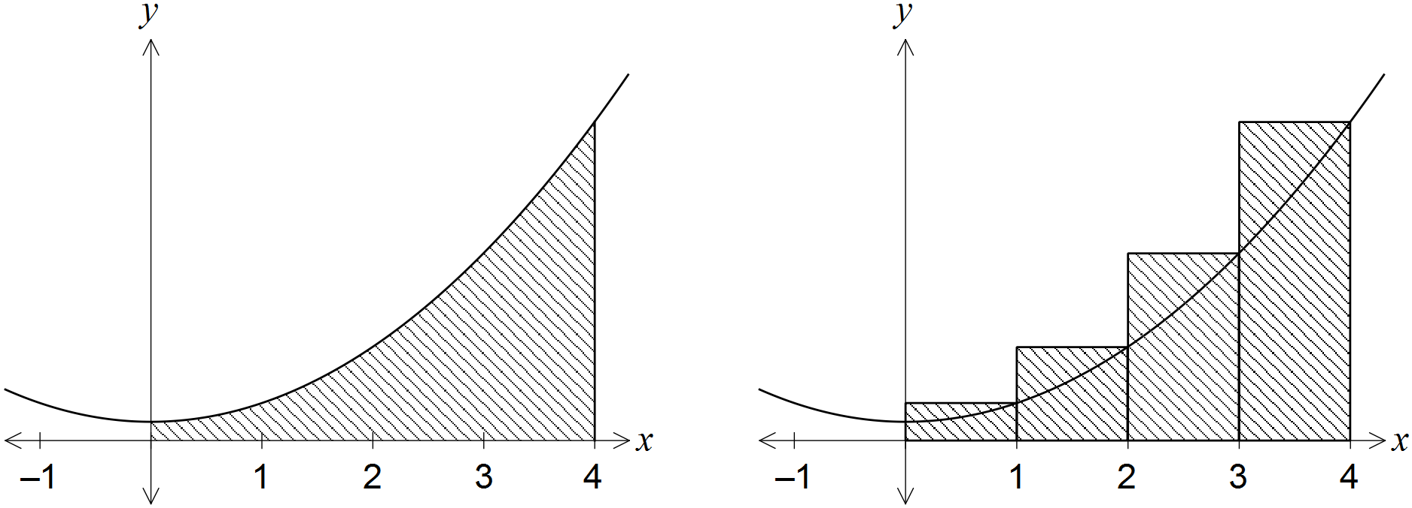

An approximation for the area beneath the curve between  and  is made using rectangles as shown in the right-hand diagram. Determine the exact amount by which the approximate area exceeds the exact area.

Question 2 (9 marks)

(a) Differentiate the following with respect to x, simplifying your answers.

(i) . (2 marks)

(ii) . (3 marks)

(b) Determine the values of the constants a, b and c, given that  when . (4 marks)

Question 3 (6 marks)

A function  is such that , where a is a constant and the graph of  has a stationary point at (4, 8). Determine .

Question 4 (7 marks)

Consider the function defined by , .

(a) Determine the coordinates of the stationary point of . (3 marks)

(b) Use the second derivative test to determine the nature of the stationary point found in (a). (3 marks)

(c) State the global minimum of . (1 mark)

Question 5 (5 marks)

The area of a segment with central angle  in a circle of radius r is given by . Use the increments formula to approximate the increase in area of a segment in a circle of radius 10 cm as the central angle increases from  to .

Question 6 (5 marks)

(a) Differentiate , simplifying your answer. (3 marks)

(b) Evaluate . (2 marks)

Question 7 (6 marks)

The discrete random variable X has the probability distribution shown in the table below.

|  |  |  |  |  |
| --- | --- | --- | --- | --- |
|  | 0 | 1 | 2 | 3 |
|  |  |  |  |  |

Determine the value of the constant a.

Question 8 (5 marks)

The area bounded by the curve  and the lines ,  and  is exactly  square units. Determine the value of the constant k, given that .

Additional working space

Question number: _________

© 2016 WA Exam Papers. Narrogin Senior High School has a non-exclusive licence to copy and communicate this paper for non-commercial, educational use within the school. No other copying, communication or use is permitted without the express written permission of WA Exam Papers.